

**HUMAN BIOLOGY**

**UNITS 3 & 4**

**2021**

Name: _______________________________________________________

Teacher: ___________________________________________________

**Time allowed for this paper**

Reading time before commencing work: ten minutes

Working time: three hours

**Materials required/recommended for this paper**

***To be provided by the supervisor***

This Question/Answer booklet

Multiple-choice answer sheet

***To be provided by the candidate***

Standard items: pens (blue/black preferred), pencils (including coloured), sharpener, correction fluid/tape, eraser, ruler, highlighters

Special items: up to three calculators, which do not have the capacity to create or store programmes or text, are permitted in this ATAR course examination

**Important note to candidates**

No other items may be taken into the examination room. It is **your** responsibility to ensure that you do not have any unauthorised material. If you have any unauthorised material with you, hand it to the supervisor **before** reading any further.

**Structure of this paper**

|  |  |  |  |  |  |  |  |
| --- | --- | --- | --- | --- | --- | --- | --- |
| Section | Number of questions available | Number of questions to be answered | Suggested working time (minutes) | Marks available | Percentage of examination | Marks awarded | % to total |
| **Section 1 Multiple choice** | 30 | 30 | 40 | 30 | 30 |  |  |
| **Section 2 Short answer** | 8 | 8 | 90 | 100 | 50 |  |  |
| **Section 3 EA**  Unit 3 | 2 | 1 | 50 | 20 | 10 |  |  |
|  | 1  100 |  |  |
| Unit 4 | 2 | 1 |  | 20 | 10 |  |  |
|  |  |  |  | **Total** | 100 |  |  |

**Instructions to candidates**

1. The rules for the conduct of the Western Australian examinations are detailed in the *Year 12 Information Handbook 2021: Part II Examinations*. Sitting this examination implies that you agree to abide by these rules.

2. Write your answers in this Question/Answer booklet preferably using a blue/black pen. Do not use erasable or gel pens.

3. Answer the questions according to the following instructions.

Section One: Answer all questions on the separate Multiple-choice answer sheet provided. For each question, shade the box to indicate your answer. Only use a blue or black pen to shade the boxes. Do not use erasable or gel pens. If you make a mistake, place a cross through that square, then shade your new answer. Do not erase or use correction fluid/tape. Marks will not be deducted for incorrect answers. No marks will be given if more than one answer is completed for any question.

Section Two: Write your answers in this Question/Answer booklet. Wherever possible, confine your answers to the line spaces provided.

Section Three: Consists of two parts each with two questions. You must answer one question from each part. Tick the box next to the question you are answering. Write your answers in this Question/Answer booklet.

4. You must be careful to confine your answers to the specific questions asked and to follow any instructions that are specific to a particular question.

5. Supplementary pages for planning/continuing your answers to questions are provided at the end of this Question/Answer booklet. If you use these pages to continue an answer, indicate at the original answer where the answer is continued, i.e. give the page number.

**Section One: Multiple-choice 30% (30 Marks)**

This section has **30** questions. Answer **all** questions on the separate Multiple-choice answer sheet provided. For each question shade the box to indicate your answer. Use only a blue or black pen to shade the boxes. Do not use erasable or gel pens. If you make a mistake, place a cross through that square, then shade your new answer. Do not erase or use correction fluid/tape. Marks will not be deducted for incorrect answers. No marks will be given if more than one answer is completed for any question.

Suggested working time: 40 minutes.

1. The nervous system typically

(a) operates at a slower pace than the endocrine system.

(b) is more persistent than the endocrine system.

(c) affects more target cells at one time than the endocrine system.

(d) has shorter response times than the endocrine system.

2. Pressure on the skin would be carried through the

(a) efferent nervous system.

(b) somatic nervous system.

(c) autonomic nervous system.

(d) sympathetic nervous system.

3. A person was diagnosed with hypothyroidism and was treated by having her thyroid gland removed. In this case, which of the following would be correct? After surgery,

(a) less thyroid stimulating hormone (TSH) would be produced.

(b) more TSHrf would be released from the posterior pituitary.

(c) her metabolic rate would increase.

(d) she would need to take a synthetic hormone that mimics thyroxine.

4 Which of the following statements is correct?

(a) Parathyroid glands release prolactin.

(b) Cortisol is produced by the adrenal medulla.

(c) The thymus and pineal glands are both endocrine glands.

(d) Noradrenaline slows heart rate.

5. Vesicles in the axon terminals

(a) move towards the presynaptic membrane because sodium moves into the neuron.

(b) store neurotransmitters.

(c) release neurotransmitters into the synapse through diffusion.

(d) move across the synapse towards the receptors on the post synaptic dendrite.

6. The central nervous system is believed to use approximately 20% of all the body’s energy. Below is a list of events that occur during the transmission of a nerve impulse across a synapse.

i) reuptake of acetylcholine

ii) production of neurotransmitters

iii) diffusion of neurotransmitters

iv) exocytosis

v) neurotransmitter connects with receptors

Which of these events would require energy?

(a) ii), iii) and v) only

(b) ii), iv) and v) only

(c) i), ii) and iv) only

(d) i), ii) and iii) only

7. Following is a list of events that occur to prevent antigens from causing us harm.

i) core body temperature rises

ii) phagocytosis occurs

iii) cilia move in a wavelike pattern

iv) blood vessels dilate

v) sebum is released

Which of these events would occur as part of a non-specific internal response to an antigen?

(a) i), ii), and iv) only

(b) i), ii), and iii) only

(c) ii), iii) and iv) only

(d) ii), iv) and v) only

8 Symptoms of Alzheimer’s include disruptions in memory, personality and cognitive ability; while Parkinson’s symptoms include slow movements, muscle rigidity and tremors. Which part of the brain would be the most useful target for therapy for each?

(a) Alzheimer’s parietal lobe and Parkinson’s occipital lobe.

(b) Alzheimer’s frontal lobe and Parkinson’s temporal lobe.

(c) Alzheimer’s frontal lobe and Parkinson’s parietal lobe.

(d) Alzheimer’s temporal lobe and Parkinson’s frontal lobe.

Questions 9, 10 and 11 refer to the following information.

The DNA of three fossils was compared using gel electrophoresis and the results are shown below.

**End 1 End 2**

Fossil X

Fossil Y

Fossil Z

9. End 1 of the agarose gel

(a) is where the positive electrode is.

(b) is where the largest pieces of DNA would be found after the gel is run.

(c) is where the DNA is placed into the gel.

(d) would have the red electrode on its side.

10. According to the gel shown above,

(a) Fossil Y and Fossil Z are most closely related.

(b) Fossil Z has the longest pieces of DNA.

(c) Fossil X and Fossil Y are most closely related.

(d) Fossil Y has the shortest pieces of DNA.

11. Prior to being placed on the gel, all three samples of DNA would have been

(a) treated with DNA ligase.

(b) amplified using a polymerase chain reaction.

(c) cut using different restriction enzymes.

(d) inserted into a plasmid.

12. All of the following are ways in which T cells and B cells are similar, except one. Which one is **incorrect**?

(a) An antigen is presented to both of them by a Helper T cell.

(b) They both originate in bone marrow.

(c) They both act against only one particular type of antigen.

(d) When in contact with an antigen they recognise, they both activate and divide.

13. Cerumen and histamine are both

(a) part of the body’s external immune response.

(b) involved in the inflammatory response.

(c) released during a fever.

(d) part of the body’s non-specific immune response.

Questions 14 and 15 refer to the images (which are not to scale) and information below.

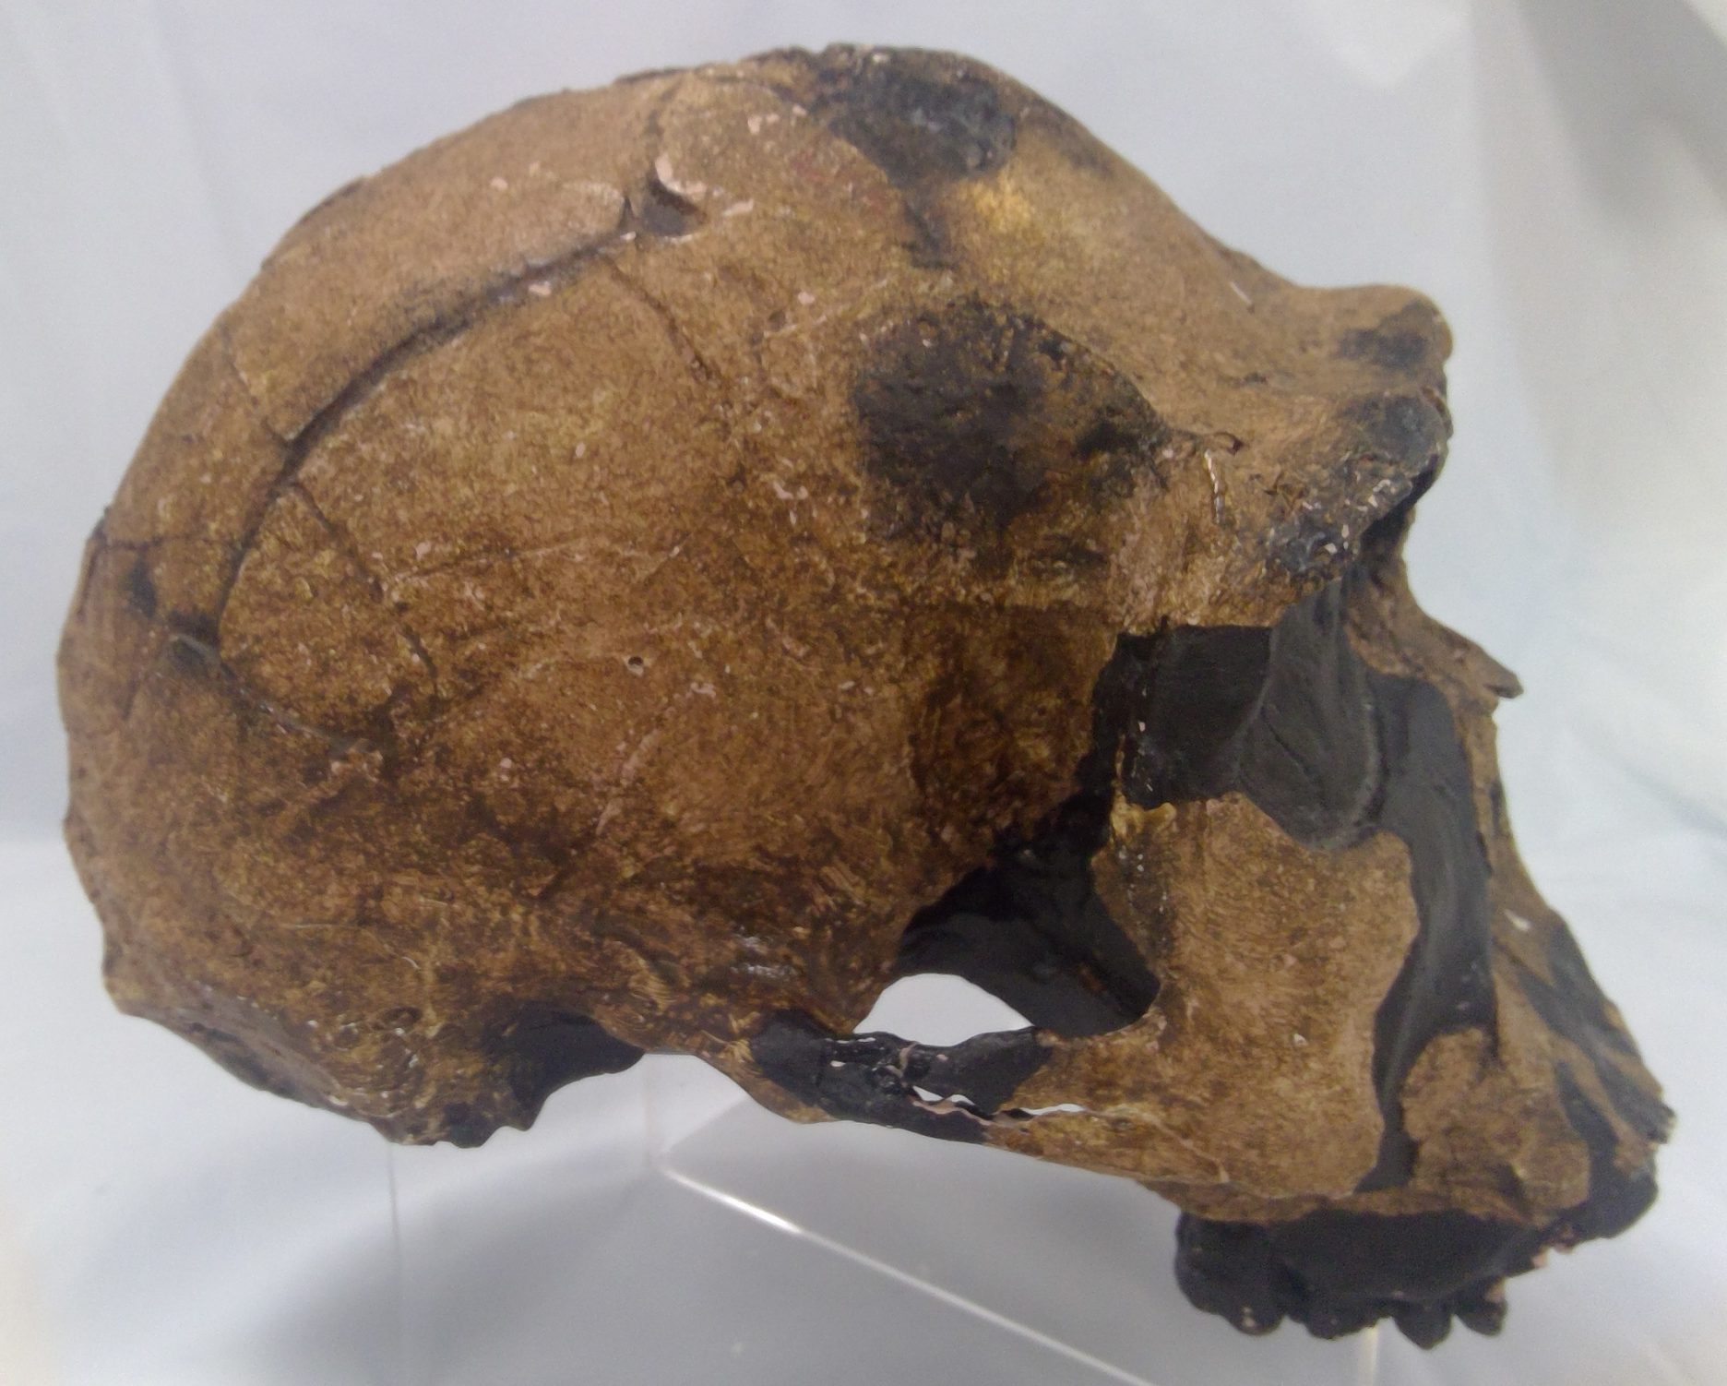 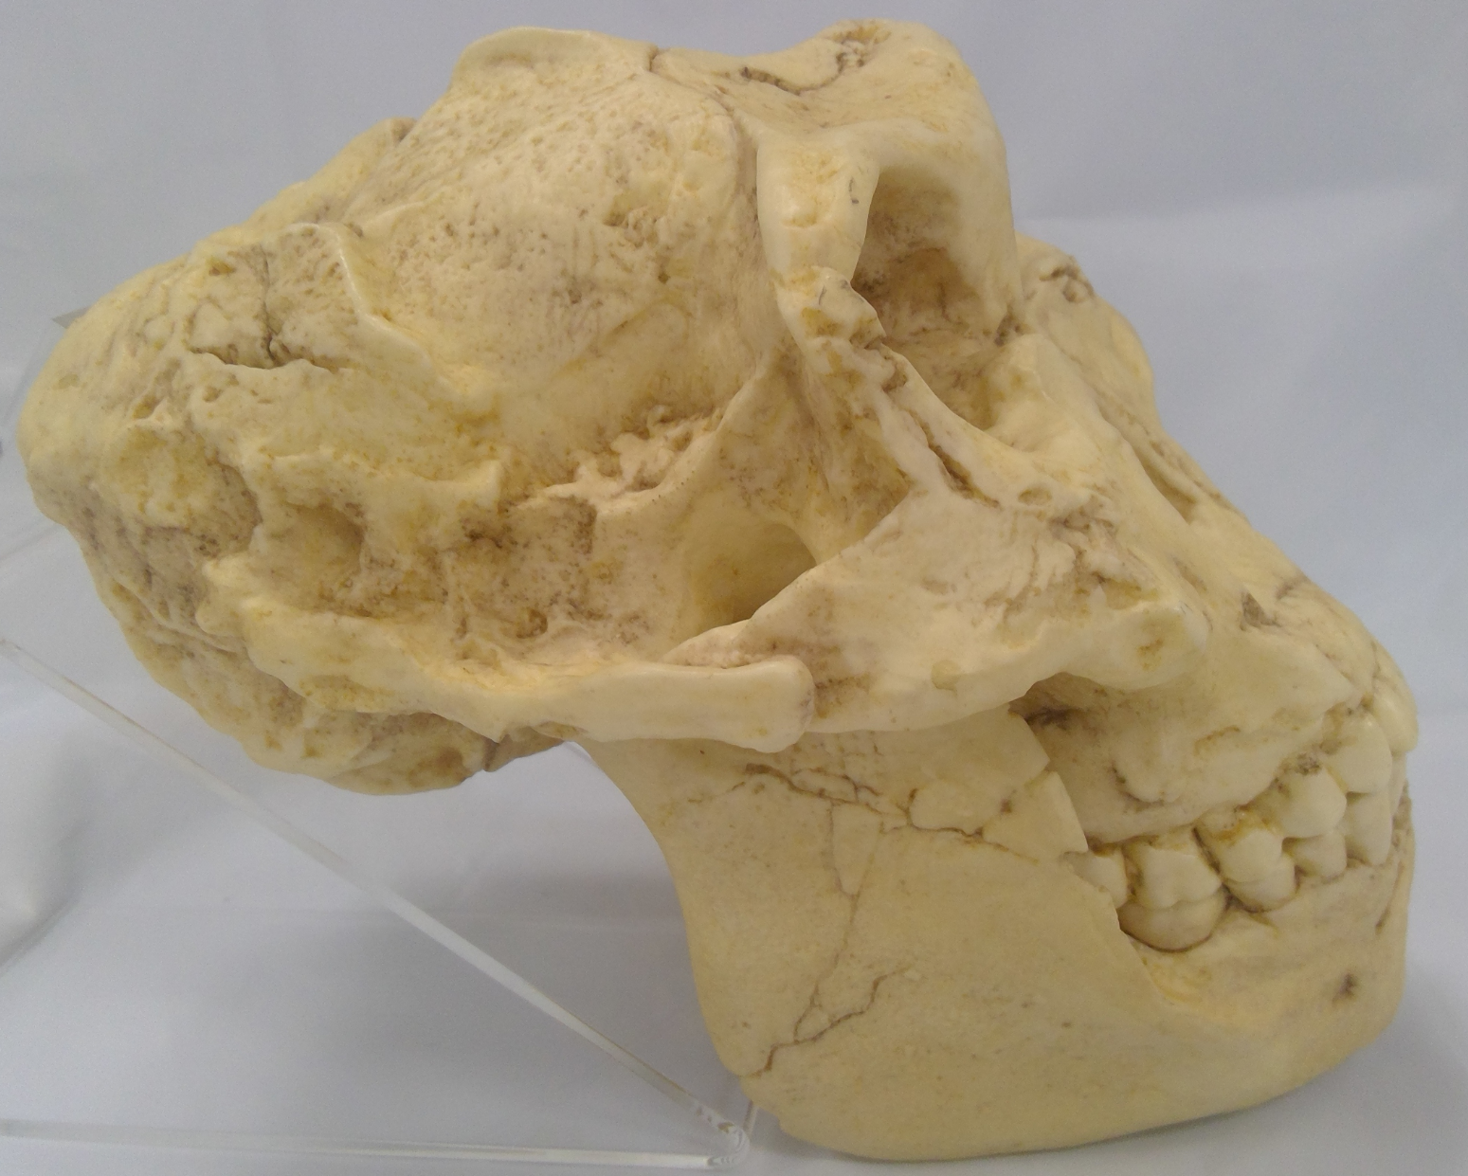 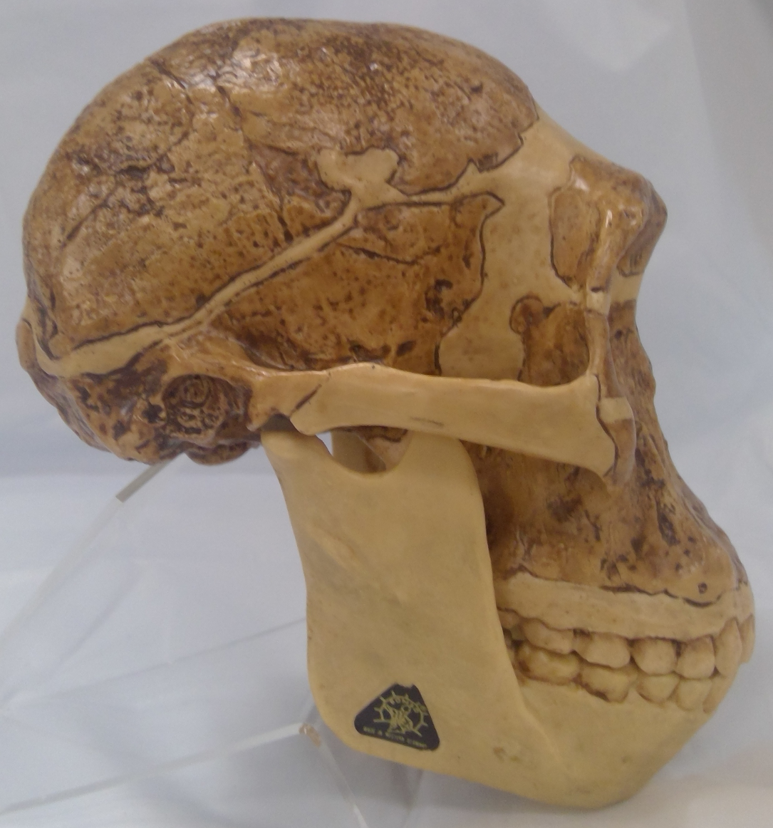

Species 1 Species 2 Species 3

Species 1 was found with stone tools and had a cranial capacity of approximately 1100cc.

Species 2 and 3 were found in South Africa.

14. Which of the following statements is **incorrect**?

(a) Species 1 is *Homo erectus*.

(b) Species 3 is believed to have made its own tools.

(c) Each of the three skulls belong to a different genus.

(d) Species 2 is not believed to be an ancestor of hominins.

15. Species 2 and 3

(a) each have an average cranial capacity of approximately 500cc.

(b) used fire.

(c) used tools in their day to day life.

(d) were both herbivores.

16. All of the following statements about index fossils are true, except one. Which one is **incorrect**?

(a) They can only be used if they are in the one location

(b) They should be found in a wide variety of geographical places

(c) They should be spread over a short period of time

(d) Pollen are good examples

Question 17 refers to the image below.

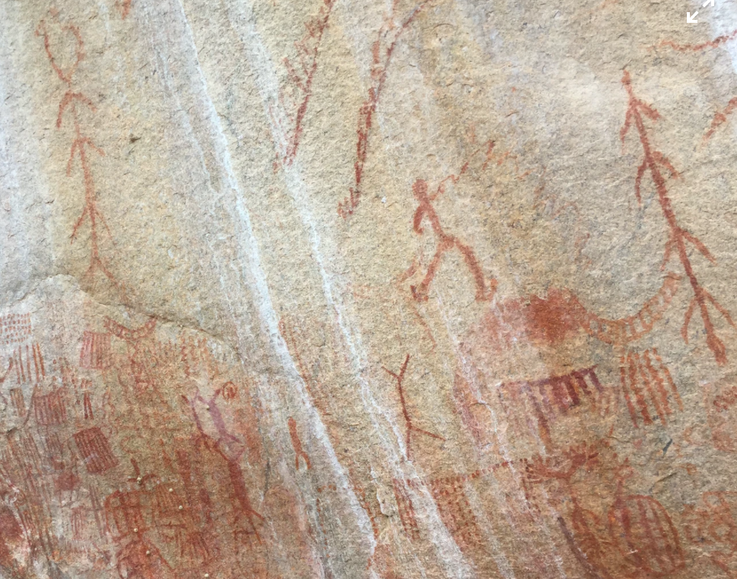

17. Cave art is first associated with

(a) *Homo erectus*.

(b) *Homo habilis*.

(c) *Homo sapiens*.

(d) *Homo neanderthalensis*.

Question 18 refers to the image of two fossils below.

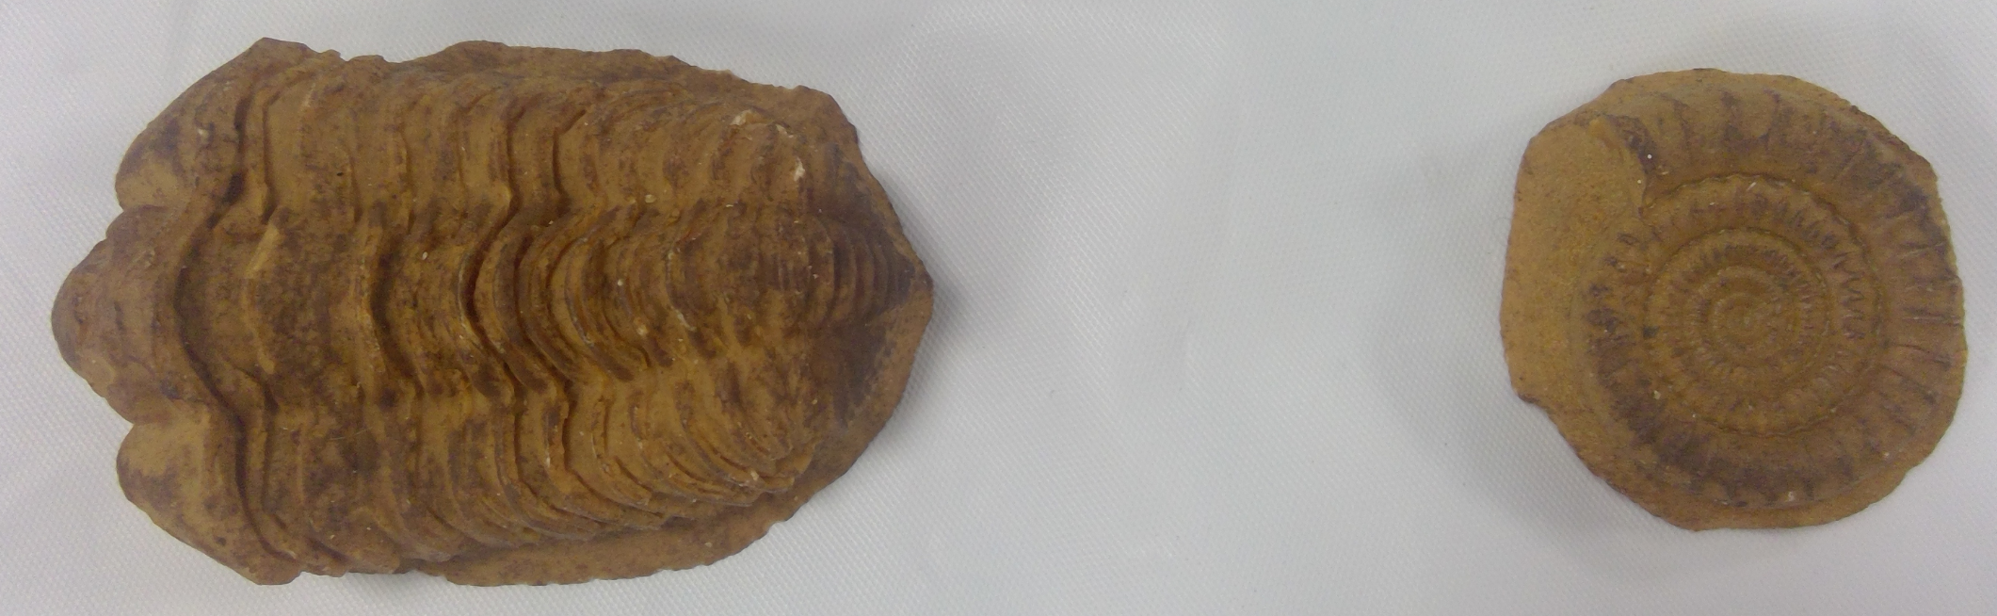

18. Below is a list of conditions that can occur after an organism has died.

i) sedimentary soil is present

ii) bacteria are present

iii) lack of oxygen available

iv) scavengers present

v) rapid burial

vi) acidic soils

vii) hot dry air

Which of these conditions would have prevented these fossils from forming?

(a) ii) and iv) only

(b) ii), iv) and vi) only

(c) iii) and vi) only

(d) iii), vi) and vii) only

Questions 19 and 20 refer to the images of lower jaws (not to scale) below.

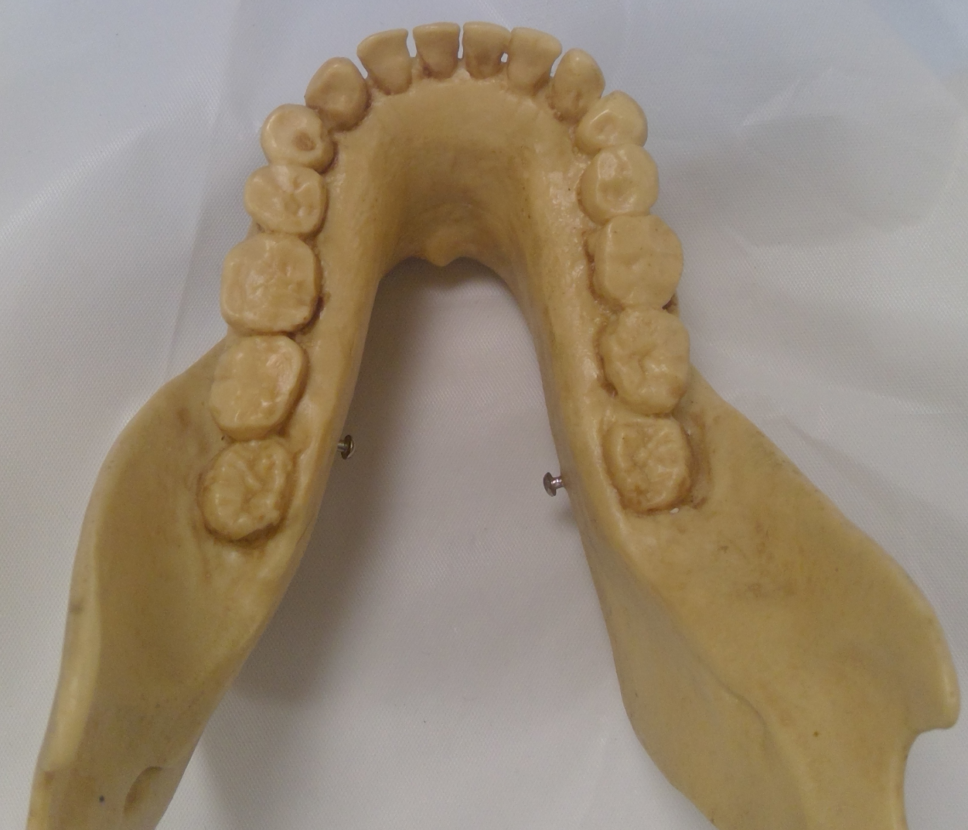 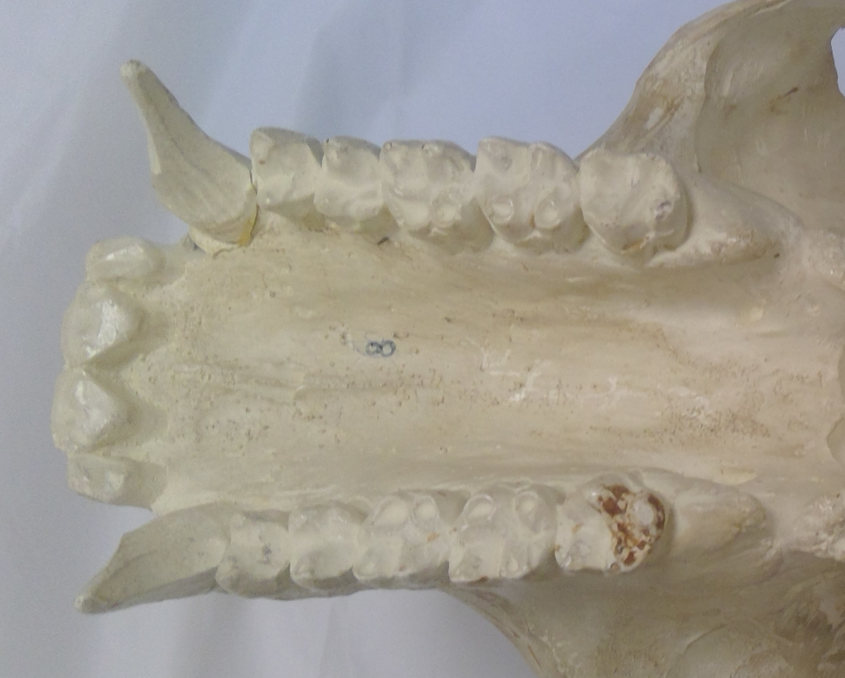 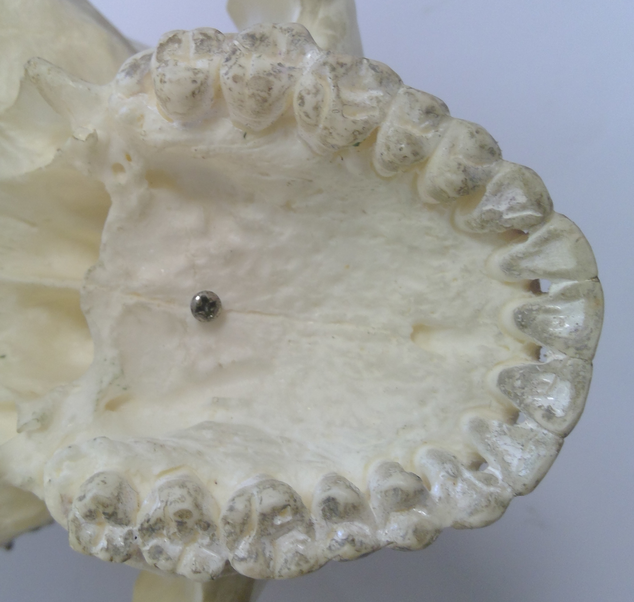

Jaw 1 Jaw 2 Jaw 3

19. Which of the following statements is correct?

(a) Jaw 1 belongs to *Homo neanderthalensis*.

(b) Jaw 1 belongs to *Australopithecus afarensis*.

(c) Jaw 2 belongs to a great ape such as *Gorilla gorilla.*

(d) Jaw 2 belongs to *Paranthropus robustus*.

20. The species that Jaw 3 has been taken from

(a) shows increased prognathism.

(b) is associated with an omnivorous diet.

(c) shows molars with a 4-cusp pattern.

(d) is an Australopithecine.

Questions 21 and 22 refer to the information below.

Scientists researching Tay-Sachs disease investigated the production of hexosaminidase

using transformed bacteria and a plasmid. Figure 1 shows where one plasmid can be cut by

5 different restriction enzymes (M, N, O, P and Q). The distance between these cutting sites

is shown in base pairs (bp).

The plasmid was cut using only three restriction enzymes and the resulting fragments were separated by gel electrophoresis. The position of the fragments in the gel is shown next to a base pair ruler in Figure 2 below.

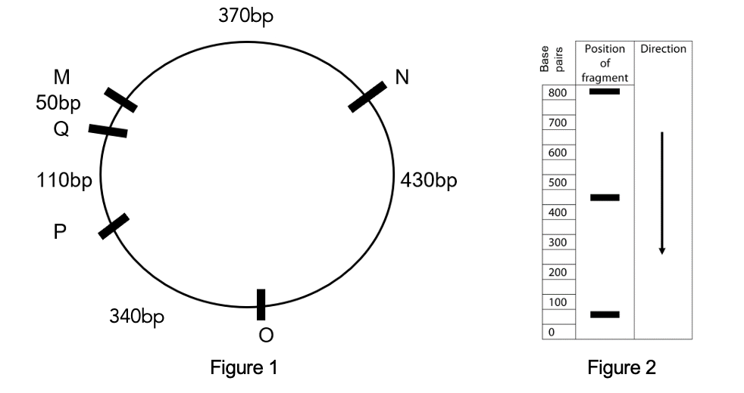

21. The restriction enzymes that were used to cut the plasmid were

(a) M, N and O.

(b) O, Q and M.

(c) O, P and Q.

(d) N, M and Q.

22. While preparing to transform a plasmid to create a vector for a trial Tay-Sachs treatment, one plasmid was accidently cut with restriction enzyme N. When a chemical was added to help join the cut sections back together again, the number of base pairs on each plasmid was not the same. This would be because

(a) not all plasmids would have been cut.

(b) not all plasmids would have re-joined.

(c) cut pieces could have joined up to other cut plasmids.

(d) their recognition sites are different in different plasmids.

Questions 23 and 24 refer to the following table which shows the temperatures (oC) required to separate hybrid DNA of four different species.

|  |  |  |  |  |
| --- | --- | --- | --- | --- |
|  | **E** | **F** | **G** | **H** |
| **E** | 86 | 84 | 80 | 81 |
| **F** |  | 86 | 81 | 80 |
| **G** |  |  | 86 | 85 |
| **H** |  |  |  | 86 |

23. Heat is used in order to

(a) denature the double helix of DNA.

(b) destroy the DNA ligase that holds the double strands together.

(c) prevent the DNA polymerase from building more DNA.

(d) speed up the process of DNA replication.

24. Hybrid DNA with high similarity will separate at higher temperatures, therefore according to the table, the two most **closely** related species are

(a) G and H.

(b) E and G.

(c) F and G.

(d) F and H.

Questions 25 and 26 refer to the image below that shows four different populations. Wherever circles overlap, interbreeding can occur.

A B A C B D

25. Population D could be isolated from the other populations for all of the following reasons, except one. Which one is **incorrect**?

(a) a large impassable mountain range separates the populations

(b) they speak a different language to the other populations

(c) they do not share the same religion as the other populations

(d) they have a different diet to the other populations

26. At one time, the environmental conditions all of the populations were exposed to changed quickly. Which population would most likely **not survive** this change?

(a) A only

(b) A and B only

(c) B and D only

(d) D only

27. A study investigated the effect of a drug on a neuron’s capacity to open sodium gated channels during an action potential. The scientists provided neurons with either no drug or a dose of the drug and measured the number of sodium gated channels open in each neuron.

The data they collected

(a) would be qualitative and objective in nature.

(b) should be graphed as a line graph.

(c) is discrete and subjective in nature.

(d) is quantitative and should be presented as a bar graph.

28. During an action potential,

(a) depolarisation results in potassium gates being opened.

(b) sodium gates are closed during repolarisation.

(c) hyperpolarisation is when sodium potassium pumps stop working.

(d) the lowest potential difference is when the cell changes from depolarisation to repolarisation.

29. Erect and bipedal organisms typically have

(a) a foramen magnum in the centre of the jaw.

(b) a transverse and longitudinal arch in their foot.

(c) arms longer than legs.

(d) a long thin pelvis.

Question 30 refers to the images below of a skull shown from two angles, that was dated at 200,000 years of age.

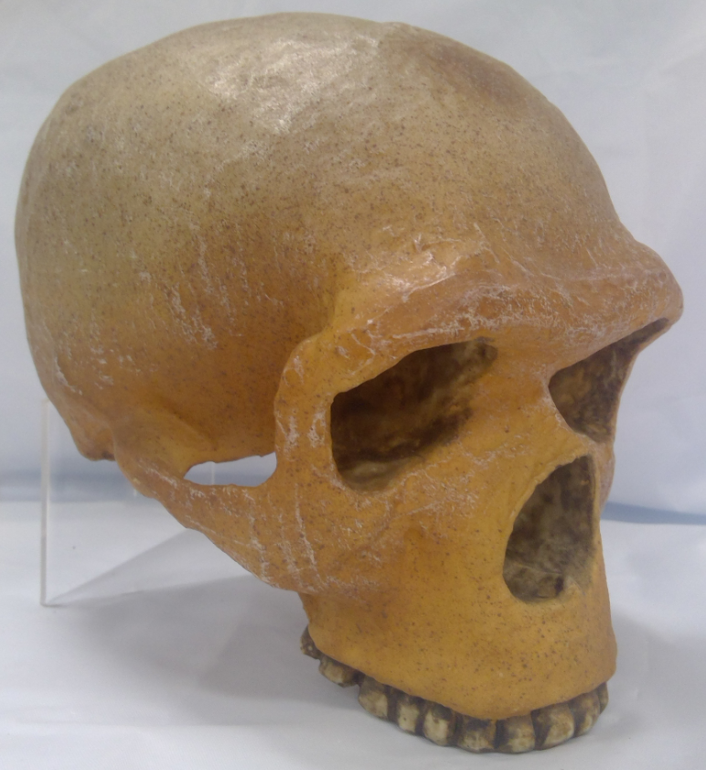 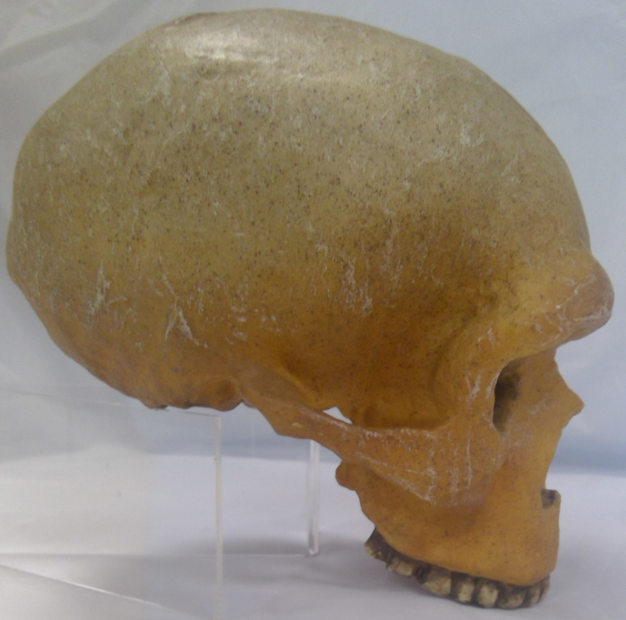

30. This species

(a) was known for hafting its tools.

(b) painted murals and made objects of art.

(c) was the first to utilise fire.

(d) produced the Aurignacian tool industry.

**End of Section One**

**Section Two: Short answer 50% (100 Marks)**

This section has **five** questions. Answer **all** questions. Write your answers in the spaces provided.

Supplementary pages for planning/continuing your answers to questions are provided at the end of this Question/Answer booklet. If you use these pages to continue an answer, indicate at the original answer where the answer is continued, i.e. give the page number.

Suggested working time: 90 minutes.

**Question 31 (15 marks)**

An AFL umpire was tested for his level of fitness by running on a treadmill in a laboratory held at 21oC. While running, his breathing rate and heart rate increased and he produced a large volume of sweat.

(a) Which part of his brain would have controlled both his breathing and heart rate?

(1 mark)

_________________________________________________________________________

(b) His breathing rate increased during the fitness test.

(i) Name the product of cellular respiration that would have caused this change in breathing rate. (1 mark)

___________________________________________________________________

(ii) Name the type of receptor that would have detected this stimulus and state where in the body these receptors are found. (2 marks)

___________________________________________________________________

___________________________________________________________________

(iii) State the effectors in his body that would have increased his breathing rate.

(2 marks)

___________________________________________________________________

___________________________________________________________________

(c) Account for the large volume of sweat that he produced during his test. (1 mark)

_________________________________________________________________________

_________________________________________________________________________

(d) During the fitness test it was noticed that the umpire’s core body temperature increased. Name the **two** main transfer mechanisms that would have allowed him to lose heat during the test and explain how each achieves a lower core body temperature. (8 marks)

_________________________________________________________________________

_________________________________________________________________________

_________________________________________________________________________

_________________________________________________________________________

_________________________________________________________________________

_________________________________________________________________________

_________________________________________________________________________

_________________________________________________________________________

_________________________________________________________________________

_________________________________________________________________________

_________________________________________________________________________

_________________________________________________________________________

**Question 32 (19 marks)**

Figure 1 below shows a nerve pathway.

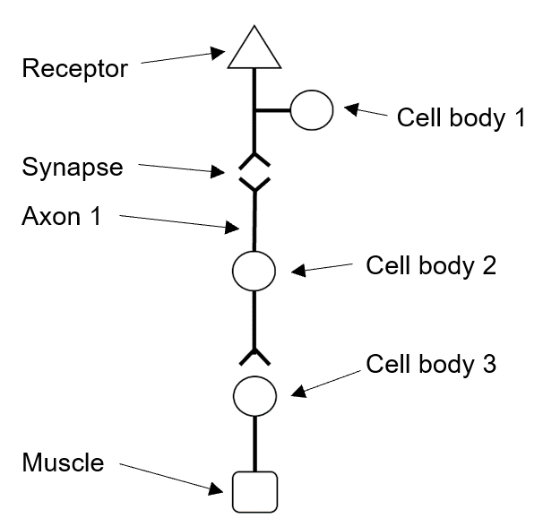

Figure 1

(a) The nerve pathway shown above can be considered to be a reflex arc. Use evidence from the image above to indicate why this might be the case. (2 marks)

_________________________________________________________________________

_________________________________________________________________________

(b) Reflex arcs are known to be the fastest of all neural processes. Why can reflexes occur faster than all other neural processes? (1 mark)

___________________________________________________________________

___________________________________________________________________

(c) Use the characteristics of how the systems function to explain why both nervous and endocrine systems are required in the body. (4 marks)

___________________________________________________________________

___________________________________________________________________

___________________________________________________________________

___________________________________________________________________

___________________________________________________________________

___________________________________________________________________

(d) Where would cell body 2 in Figure 1 be found? (1 mark)

_________________________________________________________________________

(e) Explain the role neurotransmitters play in reflex arcs. (2 marks)

_________________________________________________________________________

_________________________________________________________________________

_________________________________________________________________________

_________________________________________________________________________

(f) If the muscle shown in the pathway is a skeletal muscle, which neurotransmitter would be involved in causing it to contract? (1 mark)

_________________________________________________________________________

(g) Explain the changes required for an action potential to occur. (4 marks)

_________________________________________________________________________

_________________________________________________________________________

_________________________________________________________________________

_________________________________________________________________________

_________________________________________________________________________

_________________________________________________________________________

_________________________________________________________________________

_________________________________________________________________________

(h) A refractory period is part of all action potentials. Define the term refractory period and describe its purpose. (2 marks)

_________________________________________________________________________

_________________________________________________________________________

_________________________________________________________________________

_________________________________________________________________________

(i) Dopamine is a neurotransmitter. Too much dopamine is associated with schizophrenia. One treatment for schizophrenia is to consume a drug that fills dopamine receptors on the post-synaptic membrane. Explain how this drug might help to minimise the symptoms of schizophrenia. (2 marks)

_________________________________________________________________________

_________________________________________________________________________

_________________________________________________________________________

_________________________________________________________________________

**Question 33 (22 marks)**

Since the beginning of January 2020 until the end of February 2021, an outbreak of coronavirus (COVID-19) has seen more than 114 million people infected and more than 2.5 million die from the disease globally. Numerous countries have worked tirelessly on developing a vaccine for the disease and there are currently a number of vaccines that have recently been made available to the public.

The first study in the UK showed one dose of the Pfizer vaccine reduced the risk of hospitalisation and death by at least 75% among those over 80 years old. Researchers studied more than 12,000 people in this group in the UK after they were vaccinated to see if they fell ill, were admitted to hospital, or died. The study showed they were 57% less likely to develop symptomatic infection 28 days after the vaccination with a single dose, which increased to 88% after a second dose.

(a) What aspect of the methodology is improved by using more than 12,000 people in the study? (1 mark)

_________________________________________________________________________

(b) The more than 12,000 people who were vaccinated formed one group in the study.

(i) What is the name given to this group of people? (1 mark)

___________________________________________________________________

(ii) Describe the other group of people who would have made up this study.

(1 mark)

___________________________________________________________________

___________________________________________________________________

(c) Explain why the elderly developed more symptomatic infections after their first dose of the Pfizer vaccine compared to the number of symptomatic infections after the second dose. (2 marks)

_________________________________________________________________________

_________________________________________________________________________

_________________________________________________________________________

_________________________________________________________________________

(d) Vaccines are usually tested extensively on animals prior to them being used in human trials. Describe the key ethical points researchers would have to be aware of prior to any animal testing taking place. (3 marks)

_________________________________________________________________________

_________________________________________________________________________

_________________________________________________________________________

_________________________________________________________________________

_________________________________________________________________________

_________________________________________________________________________

(e) There are concerns in the community that people could develop COVID-19 as a result of them having been given the vaccine. With reference to sub-unit vaccines, explain why this is not a possibility. (3 marks)

_________________________________________________________________________

_________________________________________________________________________

_________________________________________________________________________

_________________________________________________________________________

(f) Some people have attended an anti-vaccine rally in Australia’s capital cities protesting against taking the vaccine. Give **three** reasons, other than thinking they may “catch” the disease from the vaccine, why people may not want to take the vaccine. (3 marks)

_________________________________________________________________________

_________________________________________________________________________

_________________________________________________________________________

_________________________________________________________________________

(g) What type of immunity is offered by the vaccine? (2 marks)

_________________________________________________________________________

_________________________________________________________________________

At the same time, another disease, Buruli ulcer disease, appeared in and around Melbourne. A type of flesh-eating disease caused by a bacterium, Buruli ulcer disease has seen a large increase in incidence in the last few years. Studies show that the bacterium that causes the disease is also found in possums and mosquitoes.

(h) State **three** ways in which viruses and bacteria are different. (3 marks)

_________________________________________________________________________

_________________________________________________________________________

_________________________________________________________________________

_________________________________________________________________________

(i) Mosquitoes are believed to be the vector for this disease. What does this mean?

(1 mark)

_________________________________________________________________________

_________________________________________________________________________

(j) Unlike COVID-19, Buruli disease can be treated with antibiotics. Explain how antibiotics affect bacteria. (2 marks)

_________________________________________________________________________

_________________________________________________________________________

_________________________________________________________________________

_________________________________________________________________________

**Question 34 (12 marks)**

Blue Fegates, also known as the “Blue People” are carriers of a genetic trait that leads to the blood disorder methemoglobinemia, which is a mutated form of haemoglobin that causes blue tinged skin. High amounts of methemoglobinemia reduces the effective release of oxygen from haemoglobin to body tissues, causing a blue appearance in affected individuals.

The image below shows the types of mutation that could be causing Blue Fegates in humans.

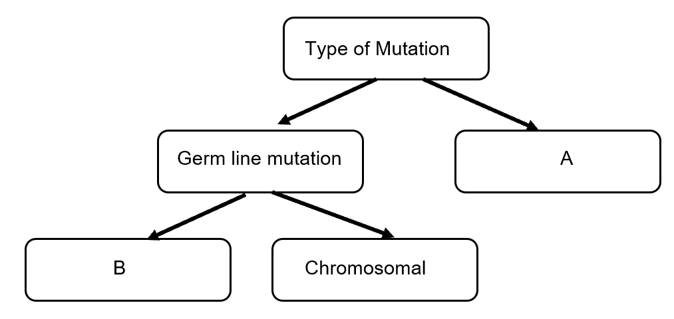

(a) State the type of mutation shown at A in the diagram above. (1 mark)

_________________________________________________________________________

(b) What does B in the diagram above represent? (1 mark)

_________________________________________________________________________

(c) State a difference between germ line mutations and the type of mutation shown at A.

(2 marks)

_________________________________________________________________________

_________________________________________________________________________

(d) Mutations can occur for a number of reasons. Explain how errors in DNA replication can result in mutations and give another example of a condition caused by mutations. (2 marks)

_________________________________________________________________________

_________________________________________________________________________

_________________________________________________________________________

_________________________________________________________________________

_________________________________________________________________________

(e) Another permanent, but often not heritable, change to DNA structure occurs as a result of errors in gamete production. Explain how errors in cell division cause changes to DNA, and give an example of a condition caused by these changes. (2 marks)

_________________________________________________________________________

_________________________________________________________________________

_________________________________________________________________________

_________________________________________________________________________

_________________________________________________________________________

(f) Suggest how the blue skin mutation in the Blue Fegates population would be affected by the process of natural selection. (4 marks)

_________________________________________________________________________

_________________________________________________________________________

_________________________________________________________________________

_________________________________________________________________________

_________________________________________________________________________

_________________________________________________________________________

_________________________________________________________________________

_________________________________________________________________________

_________________________________________________________________________

_________________________________________________________________________

**Question 35 (19 marks)**

Scientists investigated the effect of the concentration of carbon dioxide in air breathed by firefighters on their blood pH. They asked 5 firefighters to wear a full-face mask that was connected to a gas cylinder of varying carbon dioxide concentrations. During each test, the firefighters were asked to breathe normally and after 2 minutes, a finger prick test was conducted and their blood analysed to determine their blood pH. The scientists gave the firefighters a 1 minute rest between each gas test before commencing the next test. The scientists tested normal air (0.04% carbon dioxide), 0.08% and 0.12%.

(a) Write a hypothesis the scientists may have been testing. (2 marks)

_________________________________________________________________________

_________________________________________________________________________

(b) Identify the dependent variable. (1 mark)

_________________________________________________________________________

(c) Construct a table to show how these results would have been collated. (4 marks)

(d) The pH meter the scientists used could be set to give results to one or two decimal places. The scientists chose to receive their data to two decimal places. What have they improved? (1 mark)

_________________________________________________________________________

(e) Explain how the scientists improved the reliability of their investigation. (2 marks)

_________________________________________________________________________

_________________________________________________________________________

(f) The results in this experiment may not have been valid. Using evidence, explain one factor that may have affected the validity and suggest how the scientists could improve the validity of their experiment. (3 marks)

_________________________________________________________________________

_________________________________________________________________________

_________________________________________________________________________

_________________________________________________________________________

_________________________________________________________________________

_________________________________________________________________________

(g) Explain the relationship between carbon dioxide concentration and blood pH. (3 marks)

_________________________________________________________________________

_________________________________________________________________________

_________________________________________________________________________

_________________________________________________________________________

(h) Before firefighters enter burning buildings, they will often unconsciously hyperventilate. Suggest how and why this may affect them. (3 marks)

_________________________________________________________________________

_________________________________________________________________________

_________________________________________________________________________

_________________________________________________________________________

_________________________________________________________________________

_________________________________________________________________________

**Question 36 (13 marks)**

A group of archaeologists in South Africa were working on a series of core samples removed from one site. Their core samples are shown below.

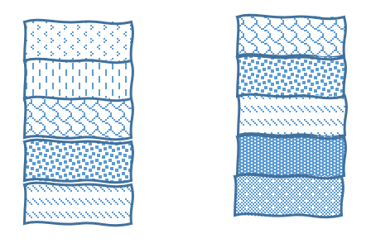

1 1

2 2

3 3

4 4

5 5

Core A Core B

(a) (i) Fossils were found in Core A layers 4 and 5 and it was determined that the

fossils found in layer 5 were older than those found in layer 4. State the dating method used to date these fossils. (1 mark)

_________________________________________________________________________

(ii) Discuss **two** limitations of this method. (2 marks)

_________________________________________________________________________

_________________________________________________________________________

_________________________________________________________________________

_________________________________________________________________________

_________________________________________________________________________

_________________________________________________________________________

(b) Charles Darwin compared the fossil record to a book, a book with some pages and some words on each page missing. Explain why the fossil record may not be complete. (3 marks)

_________________________________________________________________________

_________________________________________________________________________

_________________________________________________________________________

_________________________________________________________________________

_________________________________________________________________________

_________________________________________________________________________

Mitochondrial DNA was extracted from the fossils taken from the two layers.

(c) Explain why mitochondrial DNA is more commonly used than nuclear DNA in investigations like these. (2 marks)

_________________________________________________________________________

_________________________________________________________________________

_________________________________________________________________________

_________________________________________________________________________

DNA sequencing of a gene from both sets of mitochondrial DNA was conducted in order to

compare them.

(d) The DNA from the two fossils (fossil 1 and fossil 2) as well as two potential close relatives (relative 3 and relative 4) were studied in order to determine the evolutionary relationships between the specimens. The table below shows a portion of the DNA sequence for the same gene from each specimen.

Table 1: DNA sequence for portion of one gene

|  |  |  |  |  |  |  |  |  |
| --- | --- | --- | --- | --- | --- | --- | --- | --- |
|  | **DNA sequence in portion of one gene** | | | | | | | |
| Fossil 1 | A | A | C | G | T | T | G | A |
| Fossil 2 | A | A | C | C | T | T | A | A |
| Relative 3 | A | A | T | T | T | A | A | C |
| Relative 4 | A | C | G | A | C | G | C | T |

(i) Name one gene on which this comparison could have been made. (1 mark)

___________________________________________________________________

(ii) According to the table of DNA sequence data above, who is most closely related to fossil 1? (1 mark)

___________________________________________________________________

(iii) Construct a phylogenetic tree using the DNA sequence data in the table above. (3 marks)

**End of Section Two**

**Section Three: Extended answer 20% (40 Marks)**

This section contains **four** questions. You must answer **two** questions.

Questions 37 and 38 are from Unit 3. Questions 39 and 40 are from Unit 4. Answer **one** question from Unit 3 and **one** question from Unit 4.

Responses could include clearly labelled diagrams with explanatory notes; lists of points with linking sentences; clearly labelled tables and graphs; and annotated flow diagrams with introductory notes.

Supplementary pages for planning/continuing your answers to questions are provided at the end of this Question/Answer booklet. If you use these pages to continue an answer, indicate at the original answer where the answer is continued, i.e. give the page number.

Suggested working time: 50 minutes

_________________________________________________________________________

**Unit 3**

Choose **either** Question 37 **or** Question 38.

Indicate the question you will answer by ticking the box next to the question. Write your answer on pages 28-32. When you have answered your first question, turn to page 33 and indicate on that page the second question you will answer.

**Question 37 (20 marks)**

(a) George was an active 5-year-old who enjoyed playing outside and kicking the ball with his older brother. One week, his mother noticed he lacked energy, had lost weight and was really thirsty all the time. At the doctor’s surgery, a blood test showed that George had diabetes.

(i) Use evidence to suggest which type of diabetes George is suffering from and describe the cause of this disease. (6 marks)

(ii) Account for the symptoms George demonstrates and explain how this condition is normally treated. (6 marks)

(b) Name a lipid-soluble hormone other than testosterone or aldosterone, explain how it alters cell functioning, identify its target cells and describe the specific effects of the named hormone on the body. (8 marks)

**Question 38 (20 marks)**

(a) A Year 12 student preparing for their exams is studying so hard that they forget to drink water. Whilst the student was not under extreme conditions, both ADH and aldosterone were required to regulate body fluid concentrations. Explain how these hormones maintain body fluid homeostasis.                                                (4 marks)

(b) Due to a combination of severe dehydration and poor nutrition the Year 12 student has developed a kidney infection. The student visited their doctor who conducted a urine analysis; blood, puss and glucose were present. Additionally, a sample was sent to the pathology laboratory for analysis who detected microorganisms. These organisms were cultured. The pathologists observed the microorganisms reproducing through binary fission.

Identify the type of microorganism causing the infection and describe the specific resistance response of the students’ body. (8 marks)

(c’) Compare and contrast the structure and function of multipolar and unipolar neurons. (8 marks)

Question number: ________________

__________________________________________________________________________________________________________________________________________________

_________________________________________________________________________

_________________________________________________________________________

_________________________________________________________________________

_________________________________________________________________________

__________________________________________________________________________________________________________________________________________________

_________________________________________________________________________

_________________________________________________________________________

_________________________________________________________________________

_________________________________________________________________________

__________________________________________________________________________________________________________________________________________________

_________________________________________________________________________

_________________________________________________________________________

_________________________________________________________________________

_________________________________________________________________________

__________________________________________________________________________________________________________________________________________________

_________________________________________________________________________

_________________________________________________________________________

_________________________________________________________________________

_________________________________________________________________________

__________________________________________________________________________________________________________________________________________________

Question number: ________________

__________________________________________________________________________________________________________________________________________________

_________________________________________________________________________

_________________________________________________________________________

_________________________________________________________________________

_________________________________________________________________________

__________________________________________________________________________________________________________________________________________________

_________________________________________________________________________

_________________________________________________________________________

_________________________________________________________________________

_________________________________________________________________________

__________________________________________________________________________________________________________________________________________________

_________________________________________________________________________

_________________________________________________________________________

_________________________________________________________________________

_________________________________________________________________________

__________________________________________________________________________________________________________________________________________________

_________________________________________________________________________

_________________________________________________________________________

_________________________________________________________________________

_________________________________________________________________________

_________________________________________________________________________

_________________________________________________________________________

Question number: ________________

__________________________________________________________________________________________________________________________________________________

_________________________________________________________________________

_________________________________________________________________________

_________________________________________________________________________

_________________________________________________________________________

__________________________________________________________________________________________________________________________________________________

_________________________________________________________________________

_________________________________________________________________________

_________________________________________________________________________

_________________________________________________________________________

__________________________________________________________________________________________________________________________________________________

_________________________________________________________________________

_________________________________________________________________________

_________________________________________________________________________

_________________________________________________________________________

__________________________________________________________________________________________________________________________________________________

_________________________________________________________________________

_________________________________________________________________________

_________________________________________________________________________

_________________________________________________________________________

_________________________________________________________________________

_________________________________________________________________________

Question number: ________________

__________________________________________________________________________________________________________________________________________________

_________________________________________________________________________

_________________________________________________________________________

_________________________________________________________________________

_________________________________________________________________________

__________________________________________________________________________________________________________________________________________________

_________________________________________________________________________

_________________________________________________________________________

_________________________________________________________________________

_________________________________________________________________________

__________________________________________________________________________________________________________________________________________________

_________________________________________________________________________

_________________________________________________________________________

_________________________________________________________________________

_________________________________________________________________________

__________________________________________________________________________________________________________________________________________________

_________________________________________________________________________

_________________________________________________________________________

_________________________________________________________________________

_________________________________________________________________________

_________________________________________________________________________

________________________________________________________________________

Question number: ________________

__________________________________________________________________________________________________________________________________________________

_________________________________________________________________________

_________________________________________________________________________

_________________________________________________________________________

_________________________________________________________________________

__________________________________________________________________________________________________________________________________________________

_________________________________________________________________________

_________________________________________________________________________

_________________________________________________________________________

_________________________________________________________________________

__________________________________________________________________________________________________________________________________________________

_________________________________________________________________________

_________________________________________________________________________

_________________________________________________________________________

_________________________________________________________________________

__________________________________________________________________________________________________________________________________________________

_________________________________________________________________________

_________________________________________________________________________

_________________________________________________________________________

_________________________________________________________________________

_________________________________________________________________________

________________________________________________________________________

**Unit 4**

Choose **either** Question 39 **or** Question 40.

Indicate the question you will answer by ticking the box next to the question. Write your answer on the pages provided.

**Question 39 (20 marks)**

(a) Tasmania has an incidence of 1/3000 of Huntington’s Chorea, a genetic condition, compared to an incidence of 1/10,000 in mainland Australia. Using the concepts of random genetic drift and founder effect, explain how this difference could have arisen. (6 marks)

(b) Piltdown Man is a well-known fossil found in 1912 by Charles Dawson, an amateur collector. It was made up of nine pieces of a human-like large brained skull and an ape-like jaw with two teeth. Its find was believed to support the concept of ‘the missing link’ – a fossil that showed the relationship between apes and humans.

(i) Contrast the jaw and teeth of great apes and hominins. (6 marks)

(ii) Describe how carbon 14 dating works and explain how it could have determined that the Piltdown Man was, in fact, a fake. (8 marks)

**Question 40 (20 marks)**

(a) Tay Sachs is a fatal and incurable genetic disease that occurs in the world at a rate of about 1 in 400,000. In some populations, however, it occurs in 1 in 3600 births and, in these same populations, the incidence of being a carrier for the disease occurs at a rate of 1 in 30. Explain, using the concept of heterozygote advantage, why Tay Sachs is so much more common in some populations than in others. (6 marks)

(b) *Homo sapiens* and *Homo neanderthalensis* both existed at the same time in some parts of the world and are believed to share a common ancestor approximately 500,000 years ago.

(i) Suggest why the two species would have originated. (8 marks)

(ii) Discuss how and why bioinformatics and the polymerase chain reaction would have been used as part of this research. (6 marks)

**End of questions**

Question number: ________________

__________________________________________________________________________________________________________________________________________________

_________________________________________________________________________

_________________________________________________________________________

_________________________________________________________________________

_________________________________________________________________________

__________________________________________________________________________________________________________________________________________________

_________________________________________________________________________

_________________________________________________________________________

_________________________________________________________________________

_________________________________________________________________________

__________________________________________________________________________________________________________________________________________________

_________________________________________________________________________

_________________________________________________________________________

_________________________________________________________________________

_________________________________________________________________________

_________________________________________________________________________

_________________________________________________________________________

_________________________________________________________________________

_________________________________________________________________________

_________________________________________________________________________

__________________________________________________________________________________________________________________________________________________

_________________________________________________________________________

Question number: ________________

__________________________________________________________________________________________________________________________________________________

_________________________________________________________________________

_________________________________________________________________________

_________________________________________________________________________

_________________________________________________________________________

__________________________________________________________________________________________________________________________________________________

_________________________________________________________________________

_________________________________________________________________________

_________________________________________________________________________

_________________________________________________________________________

__________________________________________________________________________________________________________________________________________________

_________________________________________________________________________

_________________________________________________________________________

_________________________________________________________________________

_________________________________________________________________________

__________________________________________________________________________________________________________________________________________________

_________________________________________________________________________

_________________________________________________________________________

_________________________________________________________________________

__________________________________________________________________________________________________________________________________________________

_________________________________________________________________________

Question number: ________________

__________________________________________________________________________________________________________________________________________________

_________________________________________________________________________

_________________________________________________________________________

_________________________________________________________________________

_________________________________________________________________________

__________________________________________________________________________________________________________________________________________________

_________________________________________________________________________

_________________________________________________________________________

_________________________________________________________________________

_________________________________________________________________________

__________________________________________________________________________________________________________________________________________________

_________________________________________________________________________

_________________________________________________________________________

_________________________________________________________________________

_________________________________________________________________________

__________________________________________________________________________________________________________________________________________________

_________________________________________________________________________

_________________________________________________________________________

_________________________________________________________________________

_________________________________________________________________________

_________________________________________________________________________

_________________________________________________________________________

Question number: ________________

__________________________________________________________________________________________________________________________________________________

_________________________________________________________________________

_________________________________________________________________________

_________________________________________________________________________

_________________________________________________________________________

__________________________________________________________________________________________________________________________________________________

_________________________________________________________________________

_________________________________________________________________________

_________________________________________________________________________

_________________________________________________________________________

__________________________________________________________________________________________________________________________________________________

_________________________________________________________________________

_________________________________________________________________________

_________________________________________________________________________

_________________________________________________________________________

__________________________________________________________________________________________________________________________________________________

_________________________________________________________________________

_________________________________________________________________________

_________________________________________________________________________

_________________________________________________________________________

_________________________________________________________________________

_________________________________________________________________________

Question number: ________________

__________________________________________________________________________________________________________________________________________________

_________________________________________________________________________

_________________________________________________________________________

_________________________________________________________________________

_________________________________________________________________________

__________________________________________________________________________________________________________________________________________________

_________________________________________________________________________

_________________________________________________________________________

_________________________________________________________________________

_________________________________________________________________________

__________________________________________________________________________________________________________________________________________________

_________________________________________________________________________

_________________________________________________________________________

_________________________________________________________________________

_________________________________________________________________________

__________________________________________________________________________________________________________________________________________________

_________________________________________________________________________

_________________________________________________________________________

_________________________________________________________________________

_________________________________________________________________________

_________________________________________________________________________

________________________________________________________________________

Supplementary page

Question number: ________________

__________________________________________________________________________________________________________________________________________________

_________________________________________________________________________

_________________________________________________________________________

_________________________________________________________________________

_________________________________________________________________________

__________________________________________________________________________________________________________________________________________________

_________________________________________________________________________

_________________________________________________________________________

_________________________________________________________________________

_________________________________________________________________________

__________________________________________________________________________________________________________________________________________________

_________________________________________________________________________

_________________________________________________________________________

_________________________________________________________________________

_________________________________________________________________________

__________________________________________________________________________________________________________________________________________________

_________________________________________________________________________

_________________________________________________________________________

_________________________________________________________________________

_________________________________________________________________________

_________________________________________________________________________

**ACKNOWLEDGEMENTS**

Q. 15

<https://unsplash.com/photos/A9pxMWzlfW0>

<https://unsplash.com/@sofiaken/collections>

rock art

All other images are author’s own.